DS-2TS03-15XF/W
Handheld Observational Thermal Monocular

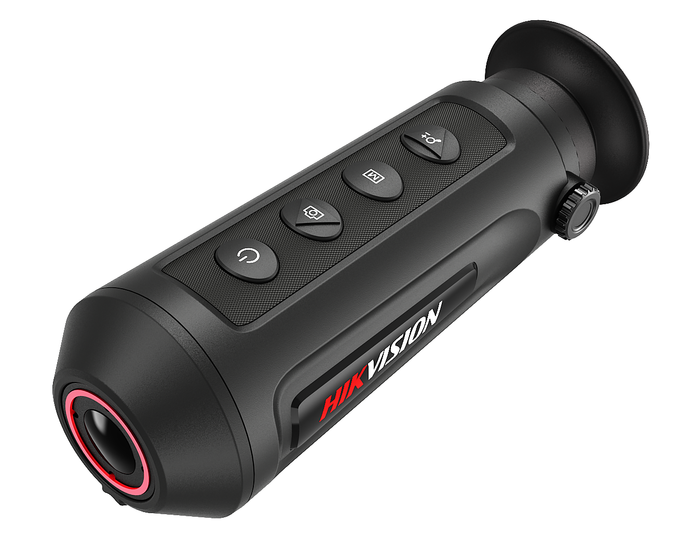

 |  |  |  |  | 

Hikvision DS-2TS03-15XF/W handheld observational thermal monocular is equipped with a 384 × 288 infrared detector and a 720 × 540 LCOS display. It supports functions of observation, highest temperature target tracking, distance measurement, Wi-Fi hot spot, and so on. The high-sensitivity built-in thermal detector provides you with clear view even in total darkness. The monocular is mainly applied to scenarios such as patrolling, law enforcement, searching and rescuing, drug enforcement, anti-smuggling, criminal seizing, hiking, travel, and hunting, etc.
Key Features
- 384 × 288 resolution, high sensitivity detector
- Adaptive AGC, DDE, 3D DNR, NETD less than 35 mk (@25°C), F#=1.0
- 720 × 540 resolution 0.2-inch LCOS display
- Built-in rechargeable lithium battery
- More than seven hours continuous running (with Wi-Fi hot spot function off)
- Wi-Fi hot spot
- Type-C Interface
Specification

Thermal Module
Image Sensor | Vanadium Oxide Uncooled Focal Plane Arrays
Max. Resolution | 384 × 288
Response Waveband | 8μm to 14μm
NETD | less than 35 mk (@25°C), F#=1.0
Lens (Focal Length) | 15 mm
IFOV | 1.13 mrad
Field of View | 24.6° × 18.5° (H × V)
Digital Zoom | 1 ×, 2 ×, 4 ×
Aperture | F1.0
Magnification | 0.6
Frame Rate | 50 fps
Image Display
Monitor | 0.2 inch, LCOS, 720 × 540
FFC (Flat Field Correction) | Auto, Manual, External Correction
Palettes | Black Hot, White Hot, Red Hot, Fusion
Smart Function
Highest Temperature Target Tracking | Yes
Wi-Fi Hot Spot | Yes
Standby Mode | Yes
System
Storage | Built-in memory module (8 GB)
Record Video | On-board video recording
Capture Snapshot | Yes
Power Supply
Battery Type | Lithium Battery
Battery Operating Time | More than seven hours continuous running (with Wi-Fi hot spot function off)
Battery Capacity Display | Yes
General
Power | 5 VDC/2 A, 1.5 W, Type-C Interface
Working Temperature | -20 °C to 55 °C (-4 °F to 131 °F)
Protection Level | IP67
Drop Test Height | 1.5 m (4.92 feet)
Dimension | 161 mm × 61 mm × 57 mm (6.34" × 2.40" × 2.24")
Weight | Approx. 270 g (0.60 lb)

Detection Range Table
* The table is only for reference, the performance may vary from camera to camera.
Wide Range Coverage
There is range limit for detecting, recognizing, and identifying human/vehicle targets.

Detection Range (Vehicles: 1.4 × 4.0 m) | Detection Range (Humans: 1.8 × 0.5 m) | Recognition Range (Vehicles: 1.4 × 4.0 m) | Recognition Range (Humans: 1.8 × 0.5 m) | Identification Range (Vehicles: 1.4 × 4.0 m) | Identification Range (Humans: 1.8 × 0.5 m)
1353 m | 441 m | 338 m | 110 m | 169 m | 55 m

Available Model
DS-2TS03-15XF/W
Dimension

